To: Ryan Yousefi, Miami New Times
Subject: [ACTION NEEDED] Exclusive Interview with Mookie Betts in South Miami
Body:
Hi Ryan,
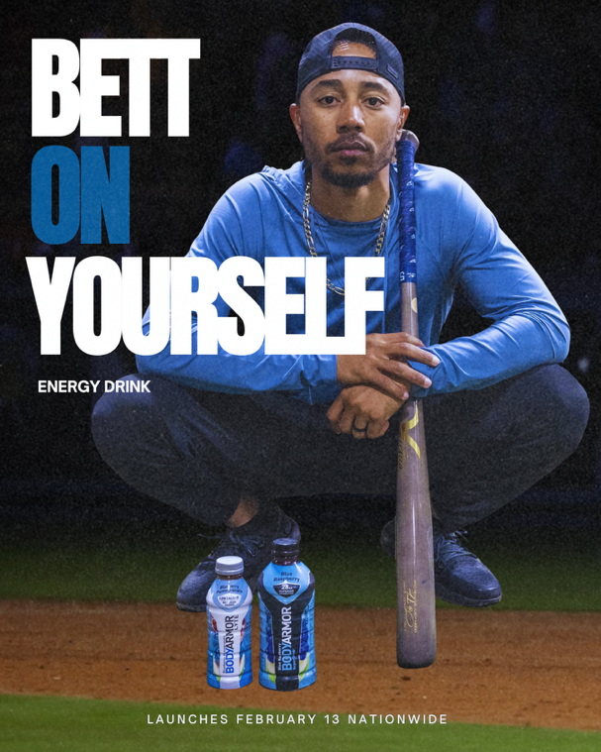
On February 10, 2026, Dodgers superstar Mookie Betts—2020 AL MVP, multi-time All-Star and Gold Glove winner, and three-time World Series champion; will be in Miami to launch his new sports energy drink, “BETT ON YOURSELF.” Available nationwide from February 13.
I am offering you an exclusive one-on-one between you and Mookie could bring compelling conversation that brings athletic insight with the motivations behind the product, and stand out as an impactful, high-profile moment in your career.
Your engaging, wide-ranging sports coverage has been a staple of your work at Miami New Times since 2013, where you blend athletic insight with lifestyle and culture in a uniquely Miami-savvy voice. That perspective is exactly what this launch deserves.
We’re offering you this exclusive 10 a.m.–11 a.m. slot in the executive room at W South Beach Hotel––just a short drive away. We envision an in-depth, engaging discussion covering:
- Mookie’s vision for “BETT ON YOURSELF,” and how it reflects his on-field discipline and off-field personality
- The intersection of athlete-driven branding, sports culture, and audience impact
This offering aligns seamlessly with your ethos of producing content that truly speaks to the passions of sports fans—while also delivering tangible, high-profile content from within our own backyard.
Kindly respond to this message by tomorrow to secure this exclusive. We’ll take care of all the logistics and product samples and ensure a seamless experience.
Thanks for your time.
Best,
Maria Leyva- Hernandez
PR Director, Los Angeles Dodgers
leyvaher@usc.edu
To: Dr. Cybil Bonhomme, Miami Vibes Magazine
Subject: [ACTION NEEDED] Exclusive Product Launch Interview with Mookie Betts in South Miami
Body:
Hi Dr. Bonhomme,
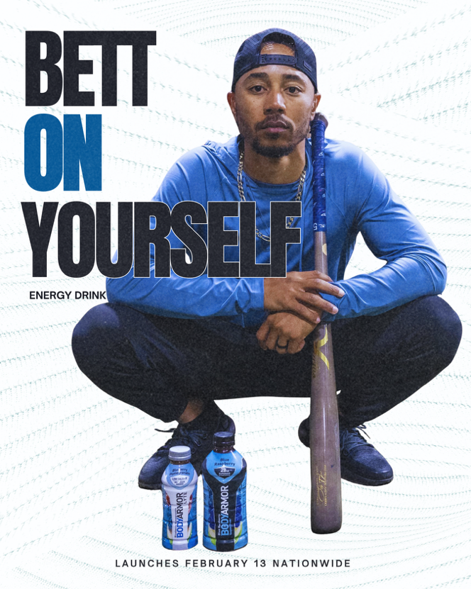
I’m reaching out with a stylish and wellness-forward opportunity that aligns beautifully with Miami Vibes’ ethos of creativity, luxury, and vibrant living.
On February 10, 2026, Dodgers superstar Mookie Betts—three-time World Series champion and one of the most-sold jerseys in Major League Baseball; will be in Miami to launch his new sports energy drink, “BETT ON YOURSELF.” Available nationwide from February 13.
“BETT ON YOURSELF” was designed for people who want more energy, focus, and wellness in their daily lives—appealing not just to athletes, but to fitness enthusiasts, entrepreneurs, creatives, and tastemakers.
We’re offering you this exclusive 11 a.m.–Noon slot in the executive room at W South Beach Hotel––just a short drive away. We envision an in-depth, engaging discussion that:
- Shares how “BETT ON YOURSELF” bridges Los Angeles’s luxury fitness culture with Miami’s wellness and lifestyle scene—two trend-setting cities leading in fitness, fashion, and celebrity influence
- Talk about his personal mantra of empowerment (“betting on yourself”) and how it connects to the wellness and motivational journey of Miami’s fitness and luxury community.
Dr. Bonhomme, your editorial vision has shaped Miami Vibes into a premier luxury and lifestyle brand. Partnering with Mookie on this launch would not only give your readers insider access to a global celebrity stepping into the wellness space but also reinforce your publication’s role in spotlighting what’s next in fitness and culture.
Kindly respond to this message by this Friday to secure this exclusive. We’ll take care of all the logistics and product samples and ensure a seamless experience.
Thank you for considering.
Best,
Maria Leyva- Hernandez
PR Director, Los Angeles Dodgers
leyvaher@usc.edu
Pitch Letter
By: Maria Leyva- Hernandez
For: PR 454 Sports Public Relations
For this assignment, I chose to pitch two journalists from a sports column with high traffic and a luxury lifestyle/fitness outlet: Ryan Yousefi of Miami New Times and Dr. Cybil Bonhomme of Miami Vibes Magazine respectively.
Ryan Yousefi is based in North Miami Beach and is a well-established voice at Miami New Times. His coverage often intersects with sports, culture, and Miami’s vibrant community, making him an ideal fit for a story on Mookie Betts’ new energy drink launch. Since the drink is tied directly to a high-profile MLB player, Ryan’s experience writing about sports-adjacent topics in a way that appeals to the broader Miami audience makes him a strong candidate to cover this event in a way that feels both relevant and engaging. He has written stories on GTA 6––an up-and-coming game that’s based in Miami, how to get tickets to the FIFA World Cup, and about fan experiences in the NHL, MLB, and NFL lenses.
On the other hand, I selected Dr. Cybil Bonhomme from Miami Vibes Magazine to represent a non-sports angle for this campaign. Miami Vibes focuses heavily on luxury, celebrities, and lifestyle trends, and Dr. Bonhomme’s editorial leadership ensures that she curates stories that resonate with Miami’s upscale audience. Since Mookie Betts is not only a professional athlete but also a public figure associated with Los Angeles—another city with similar luxury, wellness, and fitness culture to Miami—his energy drink can be positioned beyond sports. Framing the product as a lifestyle accessory for Miami’s fitness gurus and luxury wellness enthusiasts makes this pitch especially relevant to Miami Vibes. Since this a magazine of Miami lifestyle, Dr. Bonhomme would be drawn to the cultural, celebrity, and luxury angle of Mookie’s brand, which connects perfectly with her readership. I also catered the graphics in a different way to embody the sports and luxury nature of the outlets.

